Implementation Guide: Provisioning and Accessing an Azure Windows VM

1. Introduction
This document describes the process of creating and accessing a Windows Server Virtual Machine (VM) in Microsoft Azure. The objective is to deploy a VM, configure networking for remote access, and connect using Remote Desktop Protocol (RDP).
2. Environment Overview
The following configuration was used to create the virtual machine:
Virtual Machine Name | WinServer-EM15
Operating System | Windows Server 2022 Datacenter
Region | East Asia
Public IP Address | 20.189.119.67
VM Size | Standard_B2s
3. Implementation Steps
Step 1: Virtual Machine Creation
Logged into the Azure Portal, navigated to Virtual Machines, created a new resource group (RG-VM-Assignment-EM), selected Windows Server 2022 Datacenter, chose Standard_B2s size, and configured administrator credentials.
Step 2: Networking Configuration
Configured inbound port RDP (3389) for remote access. Azure automatically created a virtual network and public IP.
Step 3: Deployment
Reviewed and deployed the virtual machine successfully.
Step 4: Remote Access using RDP
Downloaded the RDP file, connected to the VM, logged in using credentials, and verified access through the Server Manager dashboard.
4. Connection Proof
The screenshot below shows successful login into the Windows Server VM with Server Manager visible.
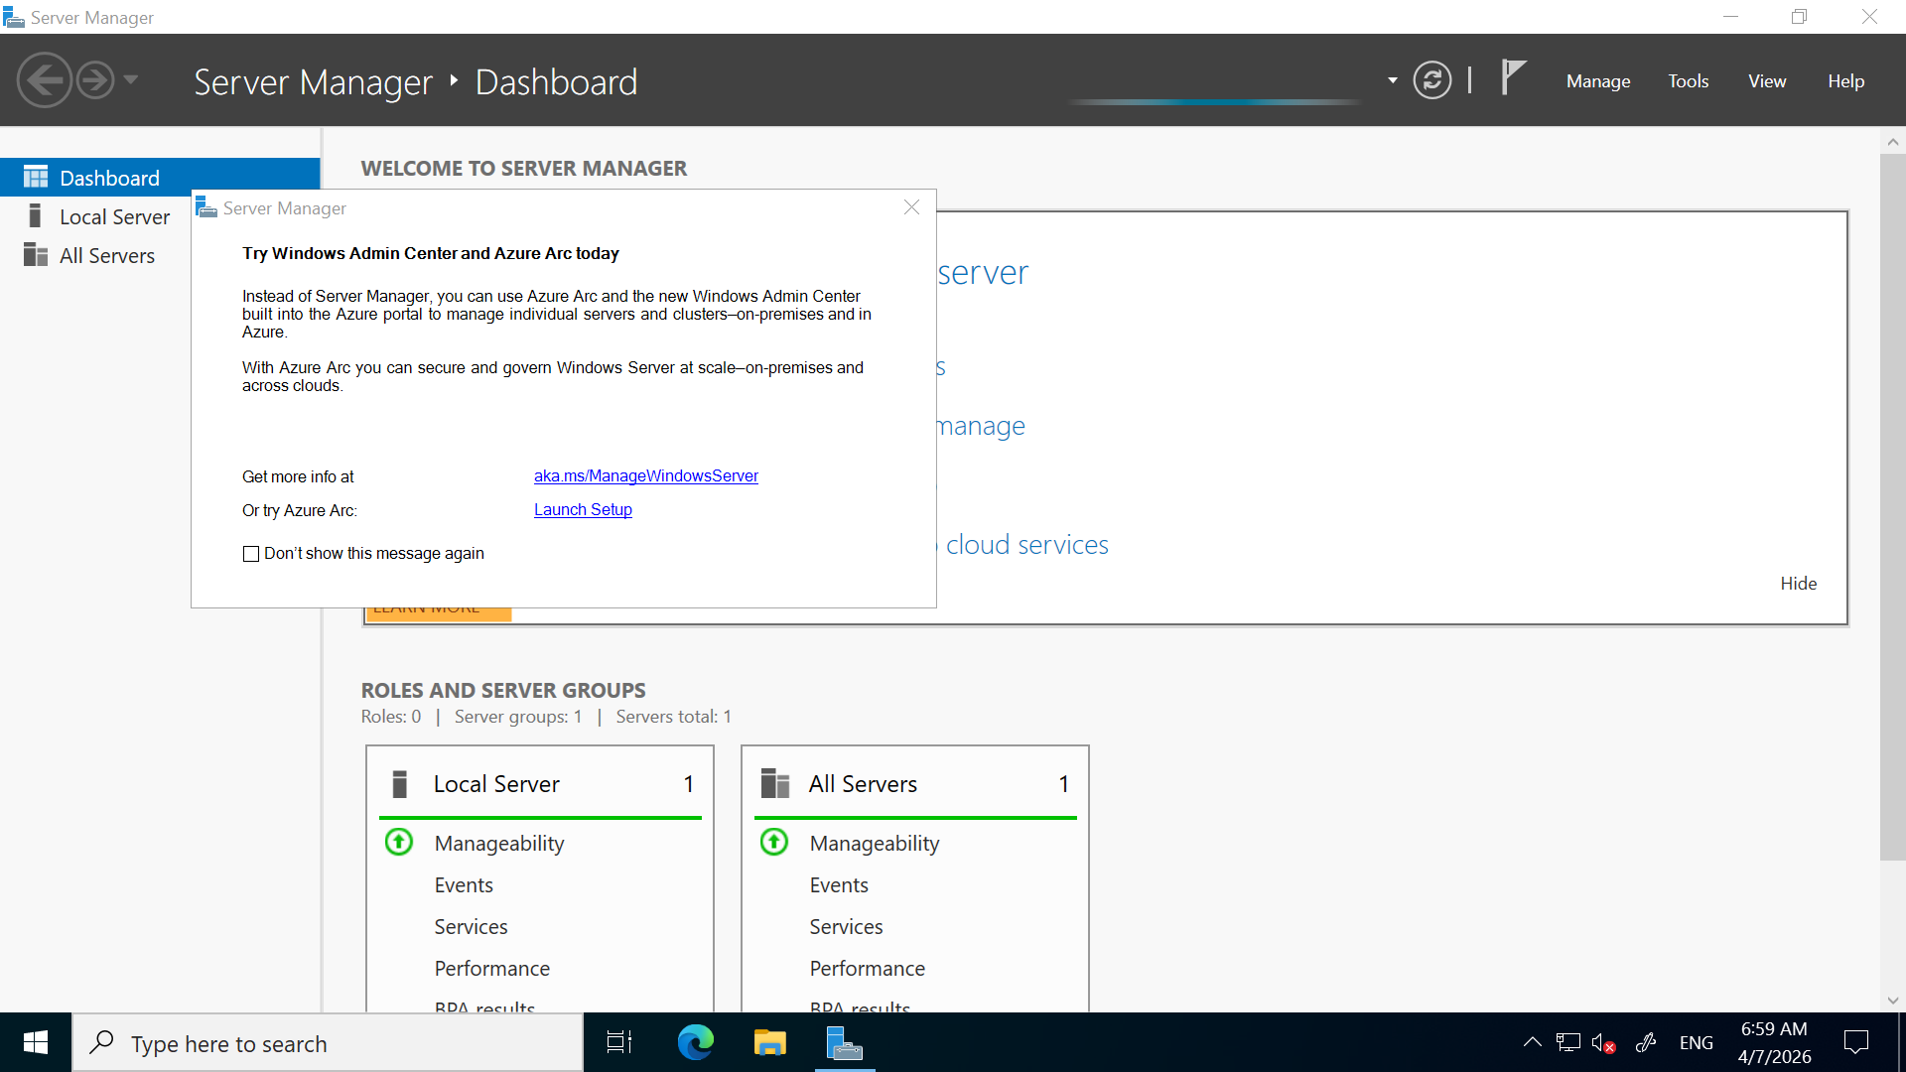
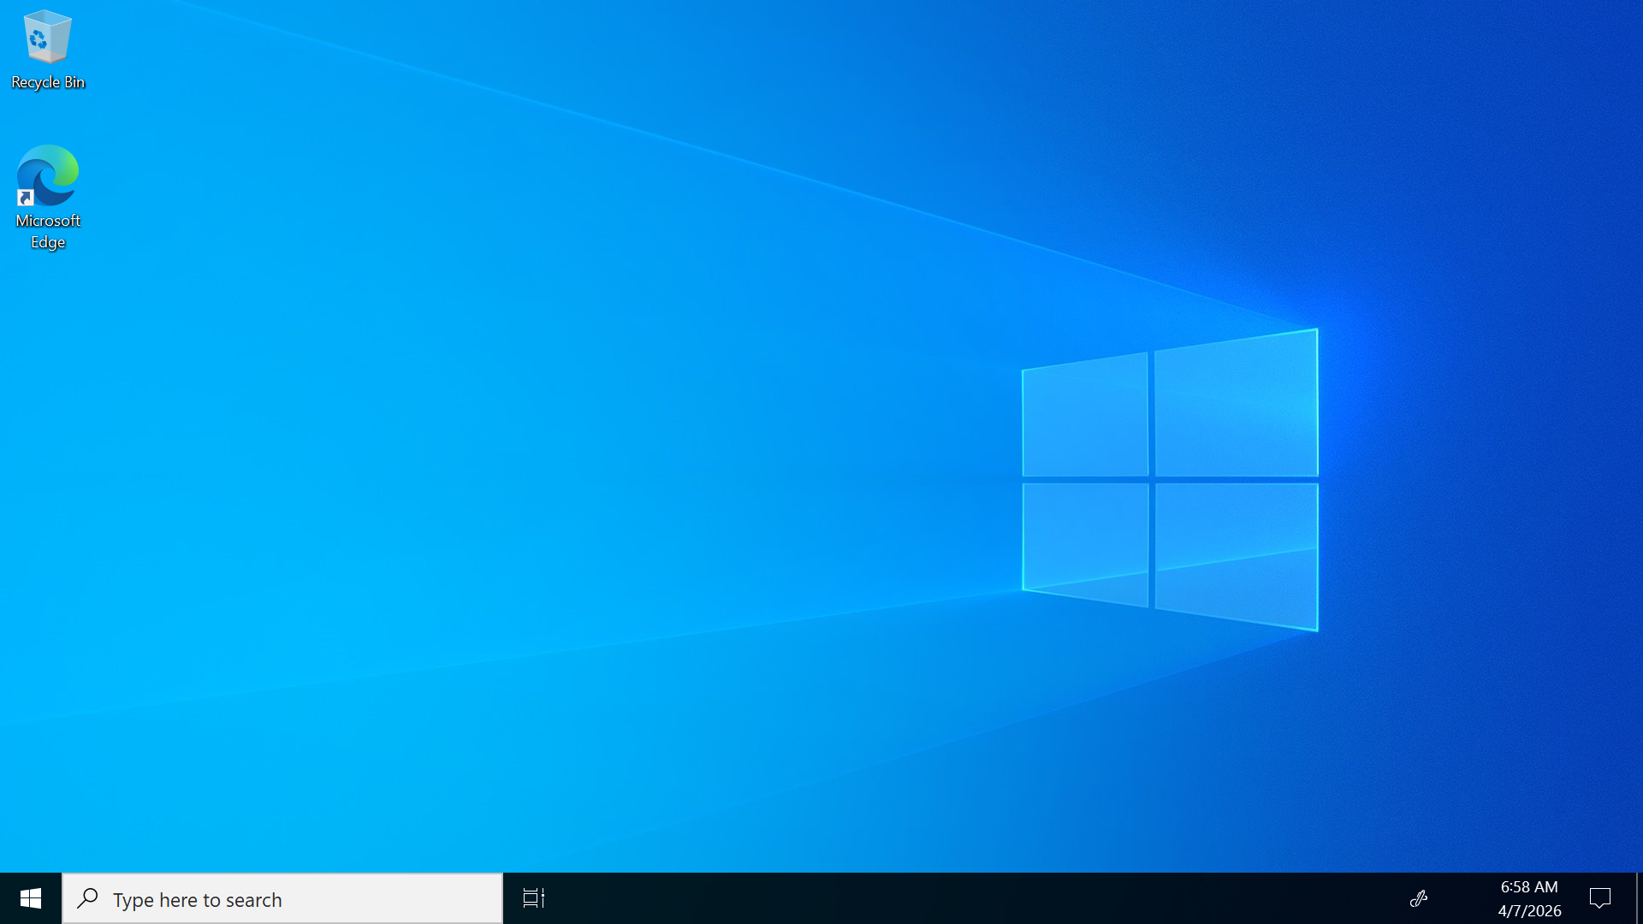
5. Resource Cleanup
The resource group RG-VM-Assignment-EM was deleted after completing the task to avoid unnecessary billing.
6. Conclusion
The task was successfully completed by creating and accessing a Windows Server VM in Azure. This exercise provided practical understanding of VM provisioning, networking configuration, and secure remote access.

